NORTHERN EDUCATION DIVISION
MALAWI SCHOOL CERTIFICATE MOCK EXAMINATIONS
CHEMISTRY marking key

Subject number: M038/II
Time Allowed: 2 hours
10:00hrs – onwards
PAPER II
PRACTICAL
(40 Marks)

Section A (20 marks)
Answer both questions in this section
- Describe how a solution of ${250 cm}^{3}$ of $0.2M$ hydrochloric acid can be prepared from a stock solution of $5M$..
$$C_{1}V_{1}=C_{2}V_{2} 1$$
$${250cm}^{3}×0.2M=5M×V_{2} 1$$
$$V_{2}=\frac{250{cm}^{3}×0.2M}{5M}=1{0cm}^{3} 1$$
- Pipette/measure ${10cm}^{3}$ of hydrochloric acid from the stock solution. 1
- Quantitatively transfer the volume of acid into a ${250dm}^{3}$ volumetric flask. 1
- Add distilled water to the volumetric flask until the solution level is just below the calibrated mark. 1
- Using a wash bottle add more distilled water drop by drop until the bottom of the meniscus is at the ${250dm}^{3}$ mark. 1
- Cork/close the volumetric flask. 1
- Invert the flask several times to make sure the solution mixes thoroughly. 1
- Transfer the solution into reagent bottle and label it $0.2M HCl$. 1

- With aid of a well labelled diagram, describe an experiment you could use to electroplate an iron metal using a silver metal (in your description include relevant chemical equations).
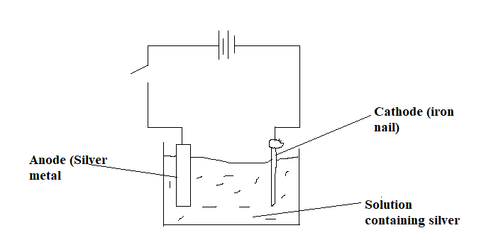
1 mark for correct diagram, 2 marks for 3 correct labels
- Set up an experiment as shown above (1)
- Close the switch and observe
- When the switch is closed, the silver metal dissolves/oxidizes by losing electrons and forms silver ions as follows (1)
$Ag (s) \overset{→}{ } Ag^{+} (aq) + e^{-}$ (1)
- The electrons travel through the external circuit to the cathode (1)
- The silver ions in the solution move to the cathode and gain an electron to become silver atoms as follows (1)
$Ag^{+} \left(aq\right)+ e^{-} \overset{→}{ } Ag (s)$ (1)
- The colour of the nail changes to silver showing that silver has been deposited on the nail (1) (10 marks)
- You are provided with the following sodium hydroxide solution in a dropper bottle, test tube rack, 3 test tubes, distilled water in a wash bottle, solutions containing Calcium ions (Ca²⁺), Aluminium ions (Al³⁺) and Iron II ions (Fe²⁺)labelled A,B and C but not necessarily in that order.
- Pour about 2ml of solution A into a test tube
- Add 3 drops of sodium hydroxide solution into the test tube
- Shake the testubes
- Note and record your observation in the table below
- Further add 15 drops of sodium hydroxide solution into the test tube
- Note and record your observation in the table below
- Repeat steps (a) to (f) using solutions B and C respectively
Solution | Addition of 3 drops of sodium hydroxide solution | Further addition of 15 drops of sodium hydroxide solution
A | Pale green precipitate | Does not dissolve/insoluble
B | White precipitates | Dissolve/soluble
C | White precipitates | Does not dissolves/insoluble
1 mark for each correct answer (6 marks)
- Identify the ions
A: Iron (II) ions/ Fe²⁺
B: Aluminium ions/ Al³⁺
C: Calcium ions/ Ca²⁺
(3 marks)
i. Name another reagent that can be used to test for the cations above
aqueous ammonia solution (1 mark)

- You are provided with 4 test tubes, distilled water in a wash bottle, sand paper, a measuring cylinder, solutions of Copper sulphate, Zinc sulphate, Iron sulphate and magnesium sulphate, pieces of Copper, Zinc, iron and Magnesium metal.
- Measure 5 ml of copper sulphate solution and put into each of the four test tubes.
- Clean the copper, zinc, iron and magnesium metals using sand paper
- Put a piece of each metal into each of the four test tubes containing copper sulphate.
- Observe the contents of the test tubes for 2-3 minutes.
- Record the results in the table below by indicating Reaction or No reaction
- Rinse the test tubes with distilled water.
- Repeat steps (a) to (f) using solutions of Zinc sulphate, Iron sulphate and Magnesium sulphate respectively.
Solution | Copper | Zinc | Iron | Magnesium
Copper sulphate |  | Reaction | Reaction | Reaction
Zinc sulphate | No reaction |  | No reaction | Reaction
Iron sulphate | No reaction | Reaction |  | Reaction
Magnesium sulphate | No reaction | No reaction | No reaction
1 mark for any 2 correct answers (6 marks)

- Arrange the metals in order of increasing reactivity.
Copper, iron, Zinc, Magnesium (1 mark)

- State the most reducing and oxidising agents.
Most reducing agent: Magnesium 1
Most oxidising agent: Copper 1

- Name the spectator ion in the experiment.
Sulphate ion (1 mark)

END OF QUESTION PAPER
This paper contains 6 printed pages

